May 2, 2024

LawyerFirst LawyerLast Esquire

SampleFirmName

123 Address St.

CityVille, StateLand 12345

Tel: (012) 345-6789

RE: *Pl1FirstName Pl1LastName; Pl2FirstName Pl1LastName; ThirdOne ThirdName et al. v SampleCaseDefendantName et al., Case No: CaseNoSample, SampleCourtName*

Date of Crash: January 1, 2020

Date of Birth: *Pl1FirstName Pl1LastName:* January 1, 1999 [20 years old at time of crash]

*Pl2FirstName Pl1LastName:* January 2, 1990 [29 years old at time of crash]

*ThirdOne ThirdName:* January 4, 1994 [25 years old at time of crash]

Dear Mr. LawyerLast,

I am in receipt of your correspondence regarding the above-named action. I have reviewed the documentation accompanying your correspondence including medical records, information regarding the subject crash, litigation documents, and other materials, including the January 1, 2021, report from the defendant's crash reconstruction and biomechanical expert, Dr. ExpertFirst ExpertLast.

The purpose of this report is to assess the methods and conclusions of Dr. ExpertLast as they pertain to the injury potential of the subject collision, relative to Ms. and Mr. Pl1LastName and Mx. ThirdName’s post-crash diagnoses and treatment.)

**My summary opinions in this matter are as follows:**

* **Dr. ExpertLast's assertion that the subject collision did not have the capacity to cause or exacerbate any of the injuries indisputably diagnosed in Ms. and Mr. Pl1LastName and Mx. ThirdNameis lacking a foundation in science, medicine, or the facts in this case. Dr. ExpertLast's opinions are based on a confusing and disingenuous presentation of a novel and distorted approach to causality and a misrepresentation and misuse of published literature.**
* **Dr. ExpertLast's assertion that the subject crash only produced minimal and benign forces that could not have cause Ms. and Mr. Pl1LastName and Mx. ThirdName's diagnosed spinal disk and other injuries because the forces in the collision were supposedly equal to those of ordinary and benign forces is not a reliable, relevant, or validated method of assessing injury cause. Using Dr. ExpertLast's claimed delta V of 8 mph for the subject collision indicates significant occupant motion and forces that in no way resemble any of the absurdly innocuous comparisons claimed by Dr. ExpertLast. Such comparisons are demonstrably unscientific and highly misleading, and irrelevant to any disputed issues in Ms. and Mr. Pl1LastName and Mx. ThirdName's case.**
* **There is no scientific or factual basis for Dr. ExpertLast's claim that Ms. and Mr. Pl1LastName and Mx. ThirdName's previous spinal injuries could not or should not have been "exacerbated" by the subject crash. Indeed, Dr. ExpertLast's use of the term is both meaningless and misleading, and neither he nor anyone else has the faintest idea of what forces would have been required to have caused Ms. and Mr. Pl1LastName and Mx. ThirdName's previously diagnosed spinal disk and other injuries to become symptomatic, or to worsen. To suggest otherwise is frankly dishonest.**
* **The methodology and principles used by Dr. ExpertLast to arrive at his opinions regarding the risk of injury from the crash to Ms. and Mr. Pl1LastName and Mx. ThirdName are not scientifically reliable, either in general or as they were applied to the facts of this case. Despite a superficial appearance of scientific validity, Dr. ExpertLast's methods are speculative, unscientific, and unreliable, and his conclusions are meaningless.**

*My qualifications to provide opinions concerning the matters herein, particularly on issues of the causal relationship between trauma and injury, are as follows:*

I am Professor and Chair of Forensic and Legal Medicine with the Faculty of Forensic and Legal Medicine of the Royal College of Physicians (UK), and a consultant in the fields of forensic medicine and forensic epidemiology. I am credentialed as a Fellow of the Royal College of Pathologists (UK), Fellow of the Faculty of Forensic and Legal Medicine (FFLM) of the Royal College of Physicians (UK) and member of the British Association in Forensic Medicine. I hold the following relevant academic degrees and certifications: a Doctor of Medicine degree (Med.Dr.) from Umeå University, a Doctor of Philosophy (Ph.D.) in public health/epidemiology from Oregon State University, a Master of Public Health (MPH) in epidemiology and biostatistics, also from Oregon State University, a master’s degree in forensic medical sciences (MScFMS) with the Academy of Forensic Medical Sciences in the United Kingdom, i.a. In addition to my degreed education, I have completed a 2-year post-doctoral fellowship in forensic pathology at Umeå University in Sweden and hold a Diploma of Legal Medicine (DLM) with the FFLM. I am also a fellow of both the American Academy of Forensic Sciences and the American College of Epidemiology. I am a Fulbright Fellow and held a 3-year roster appointment (2017-20) with the United States Department of State as a Fulbright Specialist in the field of forensic medicine. I serve as tenured Associate Professor of Forensic Medicine at Maastricht University and a joint Clinical Professor of Psychiatry and Public Health and Preventative Medicine at Oregon Health and Science University School of Medicine, where I have taught courses for the past 24 years in forensic medicine, forensic epidemiology, and injury epidemiology. From 2005-2017 I held an appointment as an Adjunct Professor of Forensic Medicine and Epidemiology at the Institute of Forensic Medicine, Faculty of Health Sciences, Aarhus University, Aarhus, Denmark, and am a recent (2020-21) visiting professor at University of Indonesia in the Faculty of Medicine.

I have been a crash reconstructionist since 1996 and have had ACTAR accreditation (the Accreditation Commission on Traffic Accident Reconstruction) since 2005. Over the past >25 years I have participated in the reconstruction of more than 3,000 crashes, including more than 300 fatalities. From 1999 through 2007 I served as a vehicular homicide investigator for law enforcement (consultant to the state medical examiner and special deputy sheriff), and I am a former affiliate medical examiner with the Allegheny County Medical Examiner’s office.

I am a member of the American Society of Biomechanics and have more than 60 scientific publications pertaining to injury biomechanics, including a book for the Society of Automotive Engineering and taught injury biomechanics in a faculty peer-reviewed course at OHSU for 15 years. I have served as a consultant on injury biomechanics to state and federal government.

I am an associate editor of the Journal of Forensic and Legal Medicine and serve or have served as an associate editor or editorial board member of 14 additional scientific peer-reviewed journals. I have published approximately 230 scientific papers, abstracts, book chapters and books on topics that include traffic crash injuries, crash reconstruction, injury causation and injury biomechanics, including the text for Elsevier, Forensic Epidemiology: Principles and Practice (2016). My publications have been cited by other authors more than 4,700 times.

I have provided testimony in more than 400 civil and criminal trials in state and Federal courts throughout the United States, Canada, and Australia. Please see my CV for further details.

At the time of the crash,

*General comments on Dr. ExpertLast’s approach*

The purpose of Dr. ExpertLast's opinion is to provide a backdoor medical causation opinion that Ms. and Mr. Pl1LastName and Mx. ThirdName were not injured in the subject collision because he (Dr. ExpertLast) deemed any injury to be *impossible* in the crash. Dr. ExpertLast made no attempt to assess the actual probability of injury from any real-world crash like the subject collision, information which can only come from observational (epidemiologic) study of injuries associated with real world crashes, not from intellectually dishonest comparisons between one of the most common causes of injury in the US to innocuous activities of daily living. Dr. ExpertLast cites to multiple (12) publications in his 15-page report, yet none of them provide valid or reliable evidence that the injuries diagnosed in Ms. and Mr. Pl1LastName and Mx. ThirdName cannot, or did not, result from the collision that they were exposed to.

The generally accepted and peer-reviewed method of crash-related injury causation analysis for a specific individual is performed by assessing the risk of injury from the collision and comparing it to the probability that the injuries or conditions would have been present at the same point in time if the collision had not occurred. The process is referred to as a "3-step" injury causation method in which improbable alternative causes are ruled out and the single most likely cause is identified. The analysis is accomplished via the application of crash reconstruction, biomechanical, medical, and epidemiologic (risk assessment) principles.[1]-[2][3][4][5] This 3-step methodology has been extensively described in the peer-reviewed literature, been deemed generally accepted by Courts in the United States, and has been adopted as part of case law in the U.S.[6]-[7][8][9][10]

The three fundamental elements or steps of an injury causation analysis are as follows:

Whether the injury mechanism had the potential to cause the injury in question (aka general causation);

The degree of temporal proximity between the injury mechanism and the onset of the symptoms reasonably indicating the presence of the injury;

Whether there is a more likely alternative explanation for the occurrence of the symptoms at the same point in time (aka differential etiology).

Dr. ExpertLast’s frankly absurd comparisons to everyday activities and volunteer crash tests in no way addressed whether the subject collision could have caused the injuries and sequelae observed in Ms. and Mr. Pl1LastName and Mx. ThirdName, the first element of the causal analysis. Dr. ExpertLast’s blanket denial that a mechanism existed in the subject collision for any of Ms. and Mr. Pl1LastName and Mx. ThirdName’s diagnosed and persisting injuries is an uninformed assertion with no basis in science, medicine, or the facts in this case and does not constitute an assessment of the plausibility of his injuries resulting from the collision.

Dr. ExpertLast has no information on the pre-crash condition of Ms. and Mr. Pl1LastName and Mx. ThirdName’s spine, or any other part of his body. He couldn’t pick him out of a lineup and hasn’t the faintest idea of his tolerance to any type of trauma, including the subject crash. **The tolerance of an individual to forceful external loads is only defined once it has been exceeded,** not based on comparisons to studies of dissimilar forces applied to bits and pieces of dead bodies (part of the basis for Dr. ExpertLast’s opinion). A review of all of the evidence in the subject case clearly established the fact that Ms. and Mr. Pl1LastName and Mx. ThirdName’s tolerance was exceeded by the forces of the subject crash.

As Dr. ExpertLast does not (and cannot) dispute any of Ms. and Mr. Pl1LastName and Mx. ThirdName’s diagnoses, and he does not provide an alternative explanation for how his diagnosed injuries would have occurred at the same time as the collision, his analysis is incomplete, and fails to account for the undeniable evidence of injury following the crash.

The generally accepted 3-step approach to causation described above dictates that if there are no other contemporaneous competing causes for the injury that are more likely than an investigated plausible cause of the injury, then it is the investigated cause that is the most likely cause. Dr. ExpertLast simply ignored Ms. and Mr. Pl1LastName and Mx. ThirdName’s medical history like it never happened; his approach to "assessing" the cause of his injuries was to reject any evidence that he was injured in the first place. Dr. ExpertLast doesn’t consider, much less mention the fact, that there are no plausible competing causes of Ms. and Mr. Pl1LastName and Mx. ThirdName’s injuries occurring at the same time as the crash.

The concept of injury thresholds as a bright line below which no injury can occur is one that has been evaluated and rejected by the biomechanical community that is involved with the evaluation of occupant forces in motor vehicle crashes. Injury thresholds have nothing to do with the evaluation of real-world collisions and can never be used to deny the presence of a real-world injury following a collision. This is made clear in an SAE publication (J885) that summarizes human threshold data for use in government crash testing:[11]

"Such [tolerance] specifications are beyond the state-of-the-art in biomechanics except perhaps for a few academic situations. There are several difficulties which prevent a ready establishment of human tolerance levels. First, there are differences in judgment as to the specific degree of injury severity that should serve as the tolerance level. Second, large differences exist in the tolerances of different individuals. It is not unusual for bone fracture tests on a sample of adult cadavers to show a three-to-one load variation. Presumably, variations of at least this magnitude exist in the living population. Finally, most tolerance levels are sensitive to modest changes in the direction, shape, and stiffness of the loading source. The above considerations indicate that complete and precise definitions of human tolerance levels will require large amounts of data based on controlled statistical samples. Only in this way can the influence of age, size, sex, and weight be comprehensively assessed and only in this way can mean loads and statistical measures of scatter be linked to specific tolerance levels."

Crash severity analysis

*Reconstruction:*

*Can the injury potential of the subject collision be determined from crash testing of volunteers?*

Dr. ExpertLast cited to human volunteer crash testing for his opinion that Ms. and Mr. Pl1LastName and Mx. ThirdName could not have sustained any significant injury in the subject crash. The comparison between a real-world crash and the results of volunteer crash tests as a means of assessing injury causation is a practice that has been rejected by the relevant scientific and automotive engineering community as improper and unreliable. I have written and had published a number of peer-reviewed papers as well as a book on human volunteer crash testing and can state as a certainty that it is well established in the scientific literature that human volunteer testing (mostly crash testing) is not a valid basis for any determination of injury risk, probability, or cause in real world crashes. *There are no crash tests that have ever been structured like the subject crash (****rear impact of SAMPLE-MDF-DV mph delta V****), as it would be irresponsible to perform such a test.*

Earlier in this report I cited the SAE publication J885 as the basis for a quotation regarding absolute injury thresholds. This paper is an authoritative publication on the topic of human injury thresholds. In the section of the paper, on page 11, under *"4. Introduction to Biomechanics, 4.1 Test Subjects,"* is the following section:

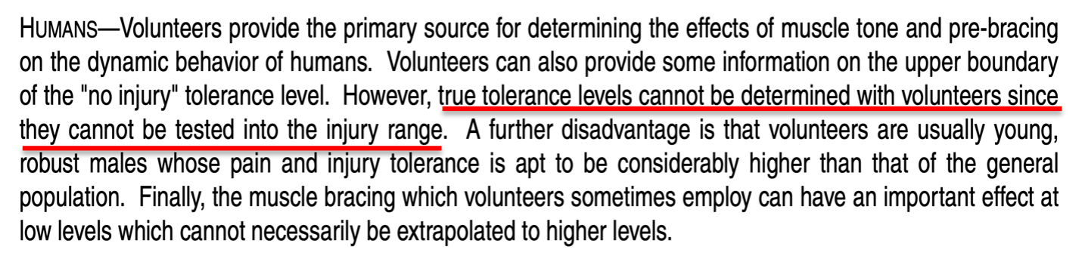

Despite the warning that "true tolerance levels cannot be determined with volunteers" from **the** authoritative publication on automotive testing and human tolerance, Dr. ExpertLast described and referred to studies primarily consisting of single rear impact collisions of less than 5 mph (with no secondary frontal crash) on healthy male volunteers, and from these papers drew the conclusion that it was essentially impossible for Ms. and Mr. Pl1LastName and Mx. ThirdName to have been injured in the subject collision.

Human volunteer crash testing is designed to *not produce injury*, and the utmost care is taken to ensure that injury is unlikely. The people who volunteer to participate in experimental crash tests are not comparable to those who are injured in similar crashes in many respects, and this includes the plaintiff. For any published crash test, the authors *typically* must secure Institutional Review Board (IRB) approval in order to assure the safety of the volunteers (this is in accordance with the Declaration of Helsinki, an international treaty on human subject experimentation).

As mentioned earlier, the peer-reviewed authoritative automotive engineering and biomechanical literature specifically states that crash tests are not an appropriate basis for any determination of real-world injury thresholds. In 1999 I published a peer-reviewed paper in the premier journal in the world on Spine surgery at that time (*Spine*), which specifically criticized some of the volunteer crash test publications cited by Dr. ExpertLast in his report for erroneously claiming an injury threshold from such testing.[12]Dr. ExpertLast presents no evidence to demonstrate that the basic scientific principles described in this 23-year old publication should be violated for his assertions regarding the cause of Ms. and Mr. Pl1LastName and Mx. ThirdName’s post-collision diagnoses and need for treatment.

*Is any collision comparable to activities of daily living?*

As noted above, Dr. ExpertLast claimed that the subject collision produced forces no greater than the loads observed in studies of "activities of daily living." Such comparisons are misleading and deceptive, and based on the junk science premise that if the occupant acceleration value of a crash can be said to be similar to that of some trivial sounding event, then this means that the injury potential of the crash and the trivial event is the same. This antiscientific myth has no application or use outside of the defense of injury litigation.

It should be patently obvious how ridiculous and frankly dishonest the comparison is between any collision and *any* everyday activity; there is no biomechanical similarity between a crash and an ADL. The direction, duration, and rapidity of acceleration that results in the kind of violent movement that occurs even in a low-speed crash is noncomparable in all respects to the self-generated, slow onset and long duration accelerations of daily activities.

The actual risk of injury from a lower speed crash is not determined by a comparison to an activity that never causes injury, of course. Such determinations are made by examining epidemiologic data regarding real world crashes and the types of injuries that result from them. This is precisely what my colleagues and I did in a recent peer-reviewed research publication, in which we noted the following:[13]

"…the theory that serves as the operating principle for the methodology, that acceleration is a proxy for injury risk in low speed or minimal damage crashes, which is the rationale for the comparison between a crash and non-injurious ADLs, is demonstrably false. Even at the lowest levels of impact severity in a rear impact crash, the results of both crash testing and epidemiologic data from real-world crashes indicate a substantial (i.e., >20%) risk of at least some degree of injury. **In contrast, everyday activities are benign events with virtually no injury risk whatsoever.**

**If the magnitude of the accelerations resulting from crashes and ADLs can be said to be even roughly comparable, this fact only serves as concrete evidence that occupant acceleration is not a proxy for injury risk."**

Regarding the novel nature of such comparisons as a basis for evaluating injury risk, we wrote:

**"There is no other example in the biomedical literature in which the established injury risk of any traumatic event is overlooked in favor of a comparison between the acceleration of the event and a non-injurious activity.** Although there may be multiple shared attributes of traffic crashes and some ADLs, just as there are multiple shared attributes of stepping down from a stair and falling down a stair (i.e., the travel distances are the same, gravity is 9.81 m/s2 in both scenarios), alluding to the absence of injury while ordinarily walking down stairs sheds no light on the frequency of injury from falling down stairs. **The comparison is inapt and should not be made."**

If we use the real world 11 km/h [6.8 mph] delta V rear impact injury risk from the present study (54%) and compare it to the highest estimated ADL-related risk (<<1 in 3,650 [0.027%] for sitting), **then even using the most conservative estimates, the crash presents a risk of injury that is at least 2,000 times greater than the "high risk" ADL of sitting.** This ratio likely underestimates the actual injury risk disparity between frontal-side impacts and ADLs by a factor of at least 10 times.

The National Highway Traffic Safety Administration (NHTSA) has recently published injury risk curves for rear impact crashes, demonstrating a rate of "MAIS 1+" (Maximum Abbreviated Injury Scale injury severity grade of 1 or more) injuries of 27% to 36% for 5 to 10 mph delta V rear impact collisions (see the red bracket in the chart below).[14] Approximately 94% of spinal disk injuries would be included in this category of injuries, as this is the rate at which disk injuries are initially diagnosed as strains in the emergency department in the first day or 2 after a crash, which is the source of the NHTSA data.[15]

The fact that Dr. ExpertLast compared an event (a less than 10 mph rear impact collision) that is irrefutably established by US national crash data to cause injury at least 1 out 4 times to ADLs which virtually **never cause injury** is a perfect illustration of how misleading and frankly dishonest the comparison is.

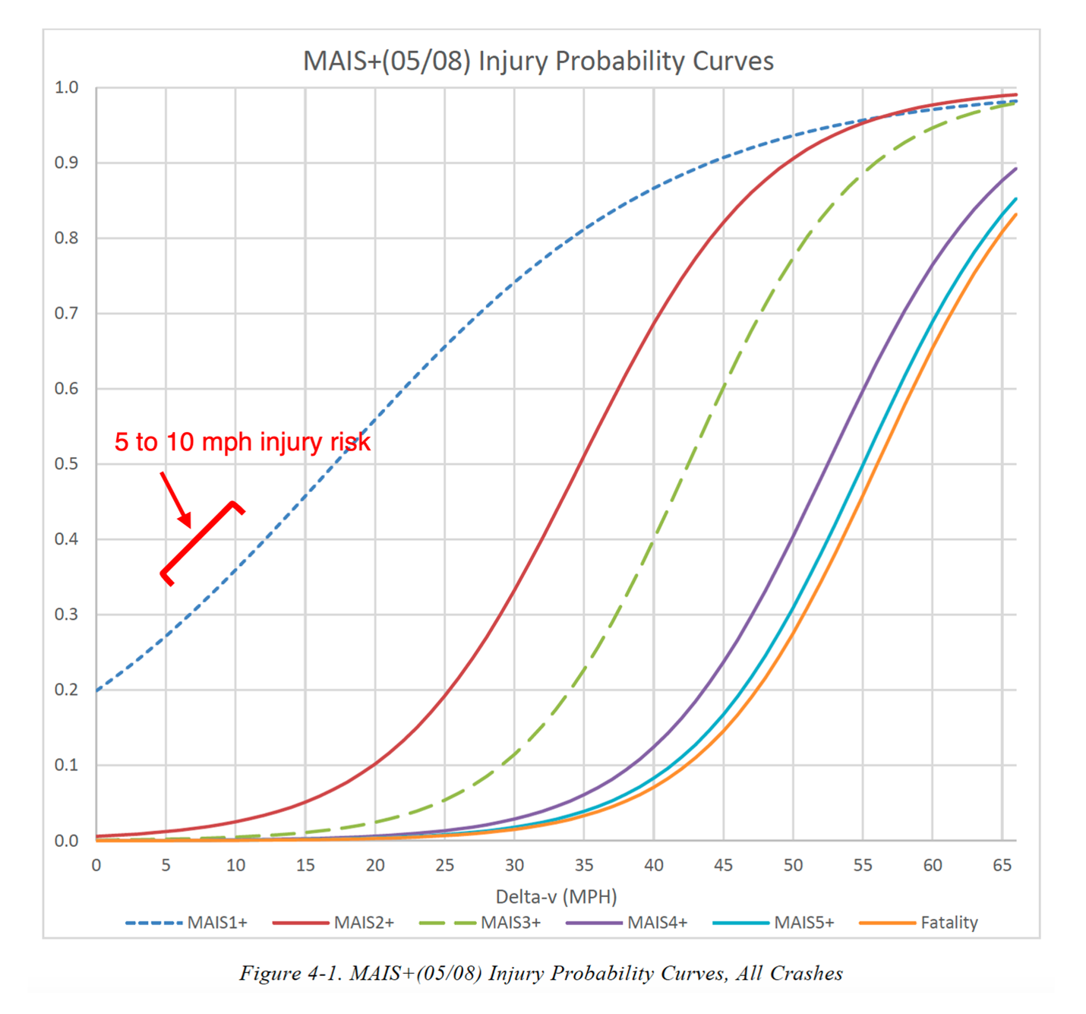

*Can a biomechanical analysis demonstrate that Ms. and Mr. Pl1LastName and Mx. ThirdName were not injured in the subject crash?*

Traumatic spinal disk injuries have been described in the peer-reviewed literature as occurring in low to moderate force events, such as minimal damage traffic crashes and roller coaster rides, but also with even more mild forces, including therapeutic manipulation of the spine, and even sneezing.[16]-[17][18][19][20][21][22] It is accurate to state that there is no established or generally accepted lower force threshold at which it can be said that an acute intervertebral disk injury in any part of the spine cannot occur. Dr. ExpertLast’s claims to the contrary are contrived and easily disproven, not to mention at odds with the specific facts in Ms. and Mr. Pl1LastName and Mx. ThirdName’s case.

Dr. ExpertLast’s offhand claim that a spinal disk could not be "exacerbated" by the subject crash (i.e., either symptomatically activated, or worsened) is a fantasy, with no theoretical, much less factual or scientific basis. In making this entirely speculative and meaningless claim, Dr. ExpertLast engages in magical thinking, which collapses under the slightest bit of scrutiny.

In his report, Dr. ExpertLast twice cited to publications on spinal disk biomechanics by a leading authority on the topic, Prof. Michael Adams. This very same author (Michael Adams PhD), in a 2012 textbook called "The Biomechanics of Back Pain,"[23] wrote that

"The magnitude of forces required to cause an individual disc to prolapse cannot reliably be predicted on the basis of gender, age, and spinal level." [page 263],

and that

"Most spinal compressive loading comes from back muscles, and forces are likely to rise to high levels during sudden and alarming incidents. These forces are difficult to quantify in retrospective analysis." [page 264],

and

"Clearly, to assume that the forces acting on the spine during whiplash are small just because the vehicle impacts are usually of low velocity would be a serious mistake. Muscle forces can be magnified in alarming situations, and if the muscles do not have time to react, then the underlying cervical spine is extremely vulnerable to bending." [pages 170-1]

It is clear that Dr. ExpertLast’s approach to providing his opinions regarding Ms. and Mr. Pl1LastName and Mx. ThirdName’s injuries is characterized by experts that he deems to be authorities in the field of spinal biomechanics as a "serious mistake."

**Conclusions**

Given the contiguous chain of causation from the day of the crash through Ms. and Mr. Pl1LastName and Mx. ThirdName’s most recent medical records, the lack of any significant pre-crash history of persisting spine pain and need for treatment in the years prior to the crash, as well as the relative risk of significant and persisting spine injury from the subject frontal impact crash, I conclude that the most probable cause of the post-crash acute and chronic neck and low back injuries described in Ms. and Mr. Pl1LastName and Mx. ThirdName’s medical records and summarized in this report, including their symptomatic cervical and lumbar disk derangements, is the subject January 1, 2020 frontal impact crash.

I have examined neither Ms. nor Mr. Pl1LastName nor Mx. ThirdName and I therefore have no opinions about their diagnoses, treatment, or prognoses outside of what is reflected in the medical record. This is not to say that I am not qualified, licensed, and extensively experienced in performing such evaluations, but that I have not done so in this case.

The preceding opinions were given as reasonable medical, and scientific probabilities. I reserve the right to amend any of my opinions should new information come to light.

Very truly yours,

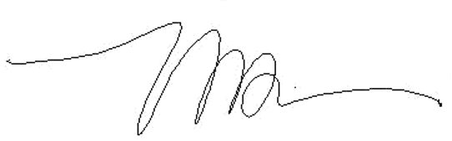

Michael D. Freeman, MedDr, PhD, MScFMS, MPH, FRCPath, FFFLM, FACE, DLM

**David Jenkins Memorial Professor and Chair in Forensic and Legal Medicine**  
Faculty of Forensic and Legal Medicine, Royal College of Physicians (London, UK)  
  
**Associate Professor of Forensic Medicine,**  
Care and Primary Healthcare Research Institute, Faculty of Health, Medicine, and Life Sciences, Maastricht University, Maastricht, Netherlands  
  
**Clinical Professor of Forensic Psychiatry**  
Department of Psychiatry, School of Medicine, Oregon Health & Science University  
  
Fellow, Royal College of Pathologists (UK)  
Fellow, Faculty of Forensic and Legal Medicine, Royal College of Physicians (London, UK)  
Fellow, American College of Epidemiology  
Member, American Society of Biomechanics

1. Melia P et al. Development of the INFERENCE (INtegration of Forensic Epidemiology and the Rigorous EvaluatioN of Causation Elements) approach to causal inference in forensic medicine. Int J Environ Res Public Health 2020;17:8353; doi:10.3390/ijerph17228353.
2. Freeman MD, Zeegers M. Principles and applications of forensic epidemiology in the medicolegal setting. Law, Probability, & Risk 2015; doi:10.1093/lpr/mgv010.
3. Koehler S, Freeman MD. Forensic epidemiology; a methodology for investigating and quantifying specific causation. Forens Sci Med Path 2014 Jun;10(2):217-22
4. Hashish R, Badday H. Frequency of acute cervical and lumbar pathology in common types of motor vehicle collisions: a retrospective record review. BMC Musculoskeletal Disorders 2017;18:437
5. Freeman MD. A practicable and systematic approach to medicolegal causation. Orthopedics 2018;41(2):70-2.
6. Freeman MD, Centeno CJ, Kohles SS. A systematic approach to clinical determinations of causation in symptomatic spinal disc injury following motor vehicle crash trauma. PM R 2009;1(10):951-6.
7. Hashish R, Badday H. Frequency of acute cervical and lumbar pathology in common types of motor vehicle collisions: a retrospective record review. BMC Musculoskeletal Disorders 2017;18:437
8. Bunketorp O (2017) WAD – Criteria for Evaluation of Causality. Open J Trauma 1(3):054-063.
9. 35 F.Supp.3d 1360 United States District Court, D. Colorado. Donald L. Etherton, Plaintiff, v. Owners Insurance Company, a Michigan Insurance Company, Defendant. Civil Action No. 10–cv–00892– PAB–KLM
10. Etherton v. Owner Insurance Company. U.S. District Court of Appeals, 10th Circuit. Case No. 14-1164.
11. Freeman MD, Leith WM. Estimating the number of traffic crash-related cervical spine injuries in the United States; an analysis and comparison of national crash and hospital data. Accident Analysis and Prevention 2020: doi:https://doi.org/10.1016/j.aap.2020.105571.
12. Freeman MD, Croft AC, Rossignol AM, Weaver DS, Reiser M. A review and methodologic critique of the literature refuting whiplash syndrome. Spine 1999;24(1):86-98.  
    (NB this paper has been cited as an authority more than 220 times in the scientific literature – see https://scholar.google.com/scholar?hl=en&as_sdt=0%2C38&q=Freeman+MD+methodologic&btnG=)
13. Nolet PS, Nordhoff L Kristman KL, Croft AC, Zeegers MP, Freeman MD. Is acceleration a valid proxy for injury risk in minimal damage traffic crashes? A comparative review of volunteer, ADL and real-world studies. Int J Environ Res Public Health 2021 2021;18:2901; https://doi.org/10.3390/ijerph18062901.
14. Wang, J.-S. (2022, May). MAIS(05/08) injury probability curves as functions of delta V (Report No. DOT HS 813 219). National Highway Traffic Safety Administration.
15. Freeman MD, Leith WM. Estimating the number of traffic crash-related cervical spine injuries in the United States; an analysis and comparison of national crash and hospital data. Accident Analysis and Prevention 2020: doi:https://doi.org/10.1016/j. aap.2020.105571.
16. Giuliano et al. The use of flexion and extension MR in the evaluation of cervical spine trauma: initial experience in 100 trauma patients compared with 100 normal subjects. Emerg Radiol. 2002;9(5):249-53.
17. Freeman et al. Significant spinal injury resulting from low-level accelerations: A case series of roller coaster injuries. Arch Phys Med Rehab 2005;86:2126-30.
18. Lutz et al. CT myelography of a fragment of a lumbar disk sequestered posterior to the thecal sac. Am J Neuroradiol 1990;11(3):610-1.
19. Sadanand et al. Sudden quadriplegia after acute cervical disc herniation. Can J Neurol Sci 2005;32(3):356-8.
20. Pappas et al. Outcome analysis in 654 surgically treated lumbar disc herniations. Neurosurgery 1992;30(6):862–6.
21. Smith J. An analysis of 72 real world impacts - an initial investigation into injury and complaint factors. SAE Technical Paper 1999-01-0640.
22. Freeman MD. Medicolegal causation analysis of a lumbar spine fracture following a low speed rear impact traffic crash. J Case Rep Prac 2015; 3(2): 23-9.
23. Adams M et al. Biomechanics of back pain. London, UK, Churchill Livingstone, 2012.